Thermo Scientific Barnstead Classic Still 2 and 5 GPH Pre-Start-Up Checklist
Instructions for Use:
- Please complete all sections of this Site Inspection form in preparation for the start-up of your new water purification system. This is a fillable form.
- Failure to have the site ready will result in delays and additional charges.
- See FAQ for water system start-up at www.thermofisher.com/installation
- Rename form with your company name on the end. Save completed form for your own records.
- Email the completed form to: servicesupport.led.asheville@thermofisher.com
Site Name
Address
Address/Bldg. Room Number
City |  | State |  | Zip
Lab Hours (from-to) |  | Weekday
Lab Contact Name |  | Lab Contact Phone |  | Extension
Lab Contact Email
Alternate Contact |  | Alt. Contact Phone |  | Extension  ( ) -  Extension
Alt. Contact Email
Purchase Order |  | Case number  (from email notification)
Special Instructions to get into facility
Section 1 - System Identification
Section 2 - Accessories and Unpacking
Section 3 - Location Requirements
Section 4 - Electrical Requirements
Section 5 - Water and Drain Specifications
Section 6 - Other Specifications and Additional Notes
Section 7 - Authorized Certification & Customer Agreement
Section 8 - Thermo Scientific Review
Section 9 - Addendum

Section 1: System Identification
- Check the Model and enter the Serial Number for the system.
- If multiple units to be set-up, please list all serial numbers below.
A1013-B-61 2 GPH, 240 V, 1 Phase
A1013-C 2 GPH, 240 V, 3 Phase
A1015-B-61 5 GPH, 240V, 1 Phase
A1015-C 5 GPH, 240V, 3 Phase
System Serial Number:
Is this unit replacing an existing water purification system?
- If Yes, what is the Model number of the unit being replaced? Serial number?
- If No, skip to section 2.
Note: Existing system must be removed and disposed of by customer.
Section 2: Optional Accessories
- Indicate which Accessories were ordered/received.
Fully Automatic Controls (FAC) - See addendum for drawing of FAC
G2100 – 2 GPH FAC Controls
G2110 – 5GPH FAC Controls
Storage Tank and Accessories
B3045* – 25G Tank
H1001 – 25G Tank Floor Stand (required with B3045 Tank)
Other Storage (please specify)__ ___________________________________
H3111 – Vent Guard and Water Seal (required for B3045 Tank)
H4005 – UV Light for Tank
H11XX - Distribution Pump
*If not ordered/received, please consult your sales representative or service engineer for guidance.
Section 2: Unpacking
- Classic Still System will arrive bolted to a pallet. All optional accessories are delivered in separate packaging.
- Unpack system and locate accessory parts as listed in the “Unpacking” section of Classic Still Manual.
- If any components are missing, please contact customerservice.led.asheville@thermofisher.com . Include model, serial number of system and missing component.

Complete system and accessories arrived and are unpacked? | Yes  No, unit is still in box/on pallet
Section 3: Location Requirements
It is the responsibility of the customer’s onsite facilities department to:
- Review space requirements, mounting instructions and precautions/warnings per system operation manual.
- Set up water system in its final location.
- Classic still comes mounted on a floor stand. Removal from floor stand will void UL approval.
- Classic still floor stand and storage tank floor stand have leveling feet and must be anchored to the floor by customer.
- Distilled water from Classic still must flow downward toward storage tank and must not be further than 30” apart.
- Location of the Classic still and tank will be determined by the water supply and drain.
It is the responsibility of Unity Lab Service to do the following:
- Set up equipment with tubing and accessories.
- Start-up system and check for leaks and proper operation.
- Training on operation and maintenance of system.
- Start-up service does not include drilling into walls, floors, or countertops.
Please complete the section below to verify where the system and accessories will be mounted.
Is Classic Still floor stand bolted to the floor in final location? |  | Yes No, not ready *
Is Storage tank floor stand bolted to the floor in final location? |  | Yes No, not ready *  NA, using non-Thermo storage
Is floor level and can support the weight of the system? |  | Yes Not sure
* If marked “Not Ready”, the water system must be in location or wall mounted before the service engineer arrives. |  | Date System will be ready: (MM/DD/YYYY)
Section 4: Electrical Requirements
It is the responsibility of the customer’s onsite facilities department to do the following:
- A licensed electrician is required to connect the main electrical power source with on/off to the Classic Still contactor box.
- Confirm electrical requirements for contactor box which provides power to the heating elements to verify the voltage and phase meets the power available in the building as noted in Chart 1 below.
- See Electrical Requirements section 4 “Installation” in the Classic Still Operation Manual for more details.
Chart 1: Classic Stills Electrical Requirements
 | Volts | Amps | Phase | Breaker
A1013-B-61 | 240 | 26 | 1 | 30 Amp, 2 pole
A1013-C | 208 | 17 | 3 | 30 Amp, 3 pole
A1015-B-61 | 240 | 57 | 1 | 60 Amp 2 pole
A1015-C | 208 | 36 | 3 | 60 Amp 3 pole

Have Electrical requirements been met? |  | Yes No
Section 5: Feed Water & Drain Requirements
It is the responsibility of the customer’s onsite facilities department to prepare the water supply and drain:
- Feed water must be connected to cold tap water with feed water pressure 40-90psi.
- See Chart 2 below for feed water specifications.
Chart 2: Classic Still Water Requirements
 | Water Supply size | Feed Water Flow Rate/Pressure | Drain Line size
A1013-B-61 | ¼” NPT | 61 L/hr. (16 GPH)  40-90psi. | ½” NPT
A1013-C | ¼” NPT | 61 L/hr. (16 G/hr.)  40-90psi. | ½” NPT
A1015-B-61 | ¼” NPT | 151 L/hr. (40 G/hr.)  40-90psi. | ¾” NPT
A1015-C | ¼” NPT | 151 L/hr. (40 G/hr.)  40-90psi. | ¾” NPT

- If the Fully Automatic Controls (FAC) HAVE NOT been purchased, the customer must supply the plumbing directly to the Condenser inlet of the still. A customer supplied shutoff valve (ball valve) and throttling valve (gate valve) must installed in the cooling water supply line, just before the still.
- If the FAC (G2100 or G2110) HAS been purchased, the inlet water line will need to be connected directly to the inlet of the FAC. See FAC drawing below.
- Atmospherically vented drain is required within 2 to 3 feet of still with downward slope. Drain must allow water flow of up to 40 GPH and temperatures up to 200°F.
- A licensed plumber should connect the inlet water and drain lines.
- ULS service technician will connect the accessories such as the FAC to the still, level monitor (included with the FAC) to the tank, start system, verify water flow rates and operation.
- Thermo Scientific will not be responsible for modifying building plumbing.

Feed water supply is connected to the Classic Still OR Fully Automatic Controls as described above? |  | Yes Not ready*
Feed water has customer supplied shutoff valve and throttling valve? |  | Yes, shutoff valve supplied  Yes, customer supplied throttling valve provided  Throttling Valve supplied w/FAC  Not ready*
Feed water is connected to cold tap water with water pressure of 40 – 90 psi? |  | Yes No
Classic still is connected to an atmospherically vented drain that is within 2 to 3 feet of still with downward slope, can handle water flow of up to 40 GPH and temperatures up to 200°F? |  | Yes No
* If you marked “Not Ready”, the water system must be set up in location before the service engineer arrives.
Section 6: Other Specifications - Distribution Pump and Loop
- If connecting a Thermo Scientific distribution pump to the still tank, a reverse acting level monitor is used to control the pump. Thermo Scientific will connect our distribution pump to our level monitor and tank for operation.
- The distribution line connections are the responsibility of the system owner.
- Non - Thermo Scientific pumps would not be installed/set up by ULS.

Will storage tank be connected to Thermo Scientific distribution pump? |  | Yes, connected to Thermo pump Will be connected to alternate supplier pump  Not connected to distribution pump
Section 6: Other Specifications – Training
- ULS technician will assemble Classic still, set-up accessories, verify proper operation of system, and provide a short training.
- The primary operator of the instrument must be available during start-up visit and for training during the initial instrument setup.
Will someone be available during set-up and training? |  | Yes No
ADDITIONAL NOTES: Please explain any “No” or “Not Ready” responses in Sections 1-6 above. Also enter additional notes and comments about the installation site or system start-up in the section below. For example, is the Classic Still going to be connected to another system?
Section 7: Customer Agreement
- I have reviewed the attached site inspection form and agree that all specifications required for the start-up of the Water Purification system can be met unless otherwise noted on this form.
- Customer acknowledges it is their responsibility to complete the activities listed above.
- If the site is not ready when the technician arrives and the start-up cannot be completed, the customer will be responsible for charges including time and travel associated with a second service call to complete the start-up (minimum time/travel fee of $300).
- Incorrectly filled out forms or misrepresentation may result in additional charges at the discretion of Thermo Fisher Scientific or their authorized partner.
- Please consult with your Field Service Engineer or Territory Sales Representative with any questions.
Customer name
Print Name
Customer Signature
Signature
Date
Section 8: To Be Completed By Authorized Thermo Fisher Service Representative On-Site
- I have reviewed the attached, completed customer site inspection form and confirm that the specifications for start-up were met.
Name of Thermo Scientific Service Representative |  | Yes No*
*If No, please make a note of missing or incorrect specifications and forward a copy of the completed form to Service Manager and Sales Representative for consultation:
Notes and Comments:

- Section 9 - Addendum Fully Automatic Controls (FAC) components shown in solid lines.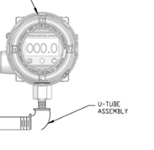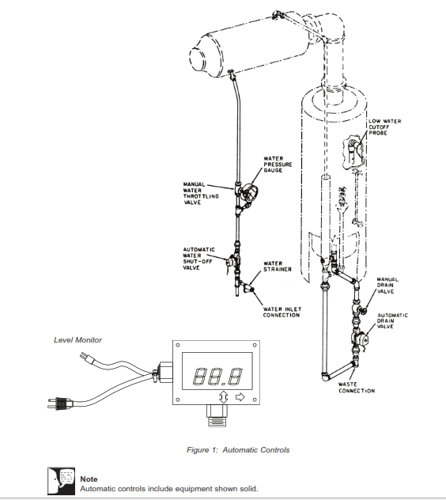
Figure 1 Fully Automatic Controls

