Instruction Sheet
  - HemaPro 2000 Probe 10K Ohm Check

- The refrigerator and freezer hemapro 2000 sensor is 10k ohm RTD. Using volt meter measure pins1 & 5 and cross reference to temperature versus resistance chart below.

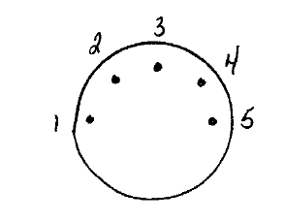

Product Serial # or model #
Revision Date: December 5, 2016

